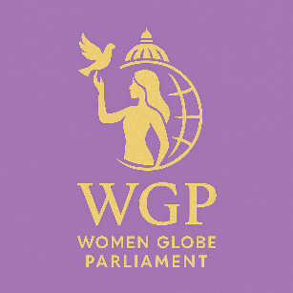

Women Globe Parliament peace and wellness– Membership & Expert Committee

Application Form Section 1: Personal Information •
Full Name:
• Date of Birth (Optional):
• Nationality:
• Country of Residence:
• Email Address:
• Phone Number:
• LinkedIn / Professional Profile (Optional):
• Preferred Communication Method:
Email / Phone / WhatsApp Section

2: Professional Background •
Current Position / Title:
• Organization / Institution:
• Years of Experience:
• Sector (Select all that apply):
• Governance / Public Policy • Parliament / Legislative Sector • Law & Justice • Education • Finance & Investment • Entrepreneurship / Business • Diplomacy & International Relations • Social Development / NGOs • Health • Technology & Innovation • Environment & Sustainability • Other (Please specify):

3: Area of Expertise (For placement in Expert Committees) Select your primary fields of expertise:
• Women’s Leadership • Gender Equality & Human Rights • Parliamentary Affairs • International Cooperation • Peacebuilding & Conflict Resolution • Business Development • Investment & Finance • Entrepreneurship Support • Youth Empowerment • Global Policy Analysis • Community Development • Economic Development • Media & Communication • Training & Capacity-Building • Other:

4: Expert Committee Selection Please choose the committee(s) you would like to join:
• Women’s Policy & Legislation Committee
• Global Investment & Business Forum Committee
• Leadership & Training Development Committee
• International Relations & Diplomacy Committee
• Peacebuilding & Security Committee
• Education & Innovation Committee
• Economic Empowerment Committee
• Sustainable Development & Environment Committee
• Youth & Next-Gen Leadership Committee (You may select up to 3 committees)

5: Motivation & Qualifications Please answer the following short questions:
1. Why do you want to join the Women Globe Parliament? (100–200 words)
2. How can your expertise contribute to our expert committees? (100–200 words)
3. List key achievements or leadership roles relevant to your chosen sector(s): (bullet points allowed) Section
6: Additional Information • Are you willing to participate in virtual meetings? Yes / No • Are you available for international forums or conferences? Yes / No • Languages spoken: ____________

• Upload CV / Portfolio (Optional) • Upload Passport-size Photo (Optional),

7: Membership Declaration “I certify that the information provided is accurate, and I agree to participate in Women Globe Parliament initiatives, leadership programs, and expert committee activities.”
• Signature / Digital Confirmation • Date,,,,,,,

